***Chapter 6 - Pointers***

A pointer is a variable that stores the address of another variable.

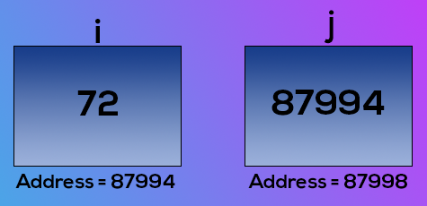

j is a pointer

j points to i.

**The "address of" (&) operator**

The address of operator is used to obtain the address of a given variable

If you refer to the diagrams above

&i=> 87994

&j=>87998

Copy

Format specifier for printing pointer address is ‘%u’

**The "value of address" operator (*)**

The value at address or * operator is used to obtain the value present at a given memory address. It is denoted by *

*(&i) = 72

*(&j) = 87994

Copy

**How to declare a pointer?**

A pointer is declared using the following syntax,

int *j; => declare a variable j of type int-pointer

j=&i =>store address of i in j

Copy

Just like pointer type integer, we also have pointers to char, float, etc.

int *ch_ptr; -> pointer to integer

char *ch_ptr; -> pointer to character

float *ch_ptr -> pointer to float

Copy

Although it's a good practice to use meaningful variable names, we should be very careful while reading & working on programs from fellow programmers.

**A Program to demonstrate Pointers:**

#include<stdio.h>

int main()

{

int i=8;

int *j;

j=&i;

printf(“Add i=%u\n”,&i);

printf(“Add i=%u\n”,j);

printf(“Add j=%u\n”,&j);

printf(“Value i=%d\n”,i);

printf(“Value i=%d\n”,*(&i));

printf(“Value i=%d\n”,*j);

return 0;

}

Copy

**Output:**

Add i=87994

Add i=87994

Add j=87998

Value i=8

Value i=8

Value i=8

Copy

This program sums it all. If you understand it, you have got the idea of pointers.

**Pointers to a pointer:**

Just like j is pointing to i or storing the address of i, we can have another variable, k which can store the address of j. What will be the type of k?

int **k;

k= &j;

Copy

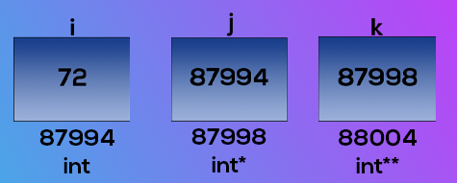

We can even go further one level and create a variable l of type int*** to store the address of k. We mostly use int* and int** sometimes in real-world programs.

**Types of function calls**

Based on the way we pass arguments to the function, function calls are of two types.

1. Call by value -> sending the values of arguments.
2. Call by reference -> sending the address of arguments

**Call by value:**

Here the values of the arguments are passed to the function. Consider this example:

int c = sum( 3 , 4 ); => Assume x=3 and y=4

Copy

If sum is defined as sum(int a, int b), the values 3 and 4 are copied to a and b. Now even if we change a and b, nothing happens to the variables x and y.

This is **call by value.**

In C, we usually make a call by value.

**Call by reference:**

Here the address of the variable is passed to the function as arguments.

Now since the addresses are passed to the function, the function can now modify the value of a variable in calling function using * and & operators. Example:

void swap(int *x, int *y)

{

int temp;

temp= *x;

*x = *y;

*y = temp;

}

Copy

This function is capable of swapping the values passed to it. If a=3 and b=4 before a call to swap(a,b), a=4 and b=3 after calling swap.

int main()

{

int a=3; // a is 3 and b is 4

int b=4;

swap(a,b)

return 0; // now a is 4 and b is 3

}

Copy

Chapter 6 - Practice Set

1. Write a program to print the address of a variable. Use this address to get the value of this variable.
2. Write a program having a variable i. Print the address of i. Pass this variable to a function and print its address. Are these addresses same? Why?
3. Write a program to change the value of a variable to ten times its current value. Write a function and pass the value by reference.
4. Write a program using a function that calculates the sum and average of two numbers. Use pointers and print the values of sum and average in main().
5. Write a program to print the value of a variable i by using the "pointer to pointer" type of variable.
6. Try problem 3 using call by value and verify that it doesn’t change the value of the said variable.